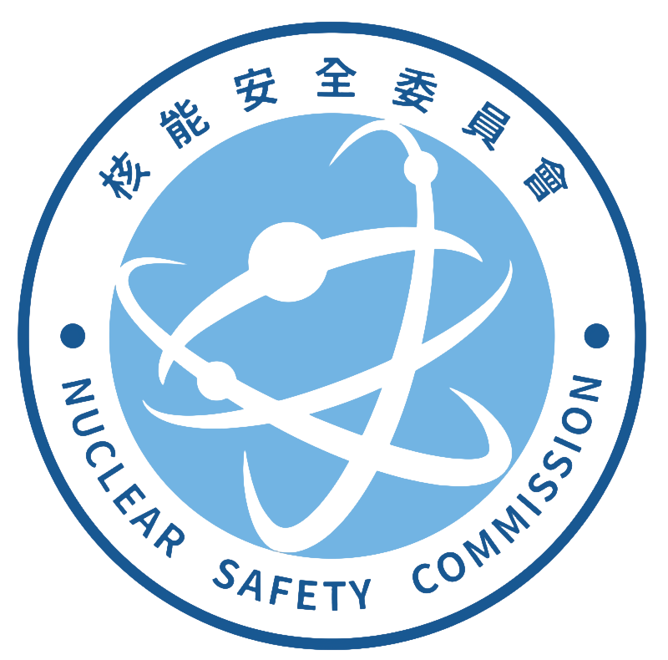
Radiation Monitoring Center, Nuclear Safety Commission
Address:833 No.823, Chengqing Rd., Niaosong Dist.,
Kaohsiung City 833, Taiwan (R.O.C.)
TEL:(07)370-9206#203 FAX:(07)370-2706
Application form for strontium-90 nuclide analysis
I. Basic information of the applicant agency RMC- Sr-
Company (Chinese): | Company (English):
Responsible person: | Contact person:
Mailing address: | Business ID number:
Telephone (including extension): | Date of Application:
II. Sample(s) basic information (⃞⃣Foodstuffs ⃞⃣Non-foodstuffs)
(1)Item Name(Chinese):________________ Item Name(English):________________ Weight (number) amount：____________
Sampling date：____________________ Batch number：_________________
Manufacture or expiration date：________________ Place of origin：________________ Package：_________________
(2)Item Name(Chinese):________________ Item Name(English):________________ Weight (number) amount：____________
Sampling date：____________________ Batch number：_________________
Manufacture or expiration date：________________ Place of origin：________________ Package：_________________
total__________________sample(s) Fee NTD $__________________
III. Testing Report(s) Format
⃞⃣Combined ⃞⃣Independent (Please select one item)
Reissue testing report of the same batch number： report(s)
(Fee of each report or supplementary report: NTD$250)
Letter of Credit No:_________________ or INV. No:_________________
IV. Comprehensive description
1. The applicant agency must first contact the organizer of the RMC by phone. After understanding the properties of the sample and accepting the commission with the consent of the RMC, the applicant will pay the fee.
2. The sample belongs to the food category,the fresh weight is 1 kilogram (edible parts). The fresh weight of tea leaves and seaweed is 200 grams.
3. The volume of water sample sent for inspection is at least 13 liters, and the dry weight of soil is at least 100 grams.
4. According to the standard procedure of RMC-O-025, the sample was measured by a proportional counter after chemical pre-treatment.
5. The testing fee for each sample is NTD$12,000. It could be paid on-site, draft or postal transfer. Account number is 04317050. Account name is 核能安全委員會輻射偵測中心. The applicant agency should indicate applicant agency name, business id number and the testing item on the transfer form.
6. The reports and receipt issued by the center are all based on the information provided by the applicant agency and others are rejected. If the payment is not completed, the RMC will not issue a report.
7. This operation shall be completed within 30 working days from the date of sample receipt. If the operation deadline is exceeded, the RMC will take the initiative to call the applicant agency to explain the processing progress and the reason for the delay.
8. Please select the method of delivery of the report: ⃞⃣Retrieve on-site; ⃞⃣Send by post.
9. Except for required by law, the RMC will keep confidential information about the performance of laboratory activities. If the detected nuclear species exceeds the legal limit value, it will be reported to the Nuclear Safety Commission according to the situation.
Application agency signature RMC signature Pay the fees(cashier)

