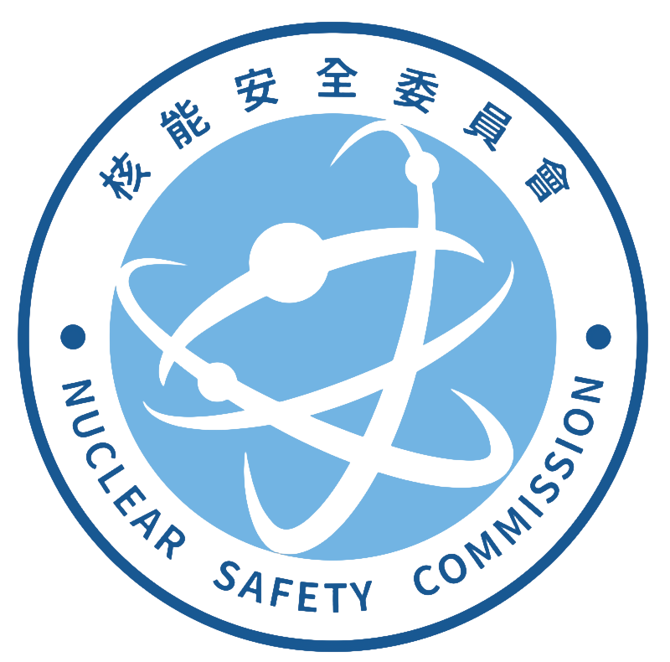
Radiation Monitoring Center, Nuclear Safety Commission
Address：No.823,Chengqing Rd.,Niaosong Dist.,
Kaohsiung City 833,Taiwan(R.O.C.)
TEL：(07)370-9206 #203 FAX：(07)370-2706
Application form for gamma spectrometric analysis
I、Basic information of the applicant agency RMC- -
Company(Chinese): | Company(English):
Responsible person: | Contact person:
Mailing address: | Business ID number
Telephone (including extension): | Date of Application:
II、Basic information of sample(s) ( ⃞⃣Foodstuffs ⃞⃣Environmental samples ⃞⃣Others )
Item Name(Chinese): __ Item Name(English): Weight (number) amount：
Sampling date： Batch number： Status：
Manufacture or expiration date： Place of origin： Package：
total sample(s) Fee NTD $
III、Testing Report(s) Format
⃞⃣Combined ⃞⃣Independent (Please select one item)
Reissue testing report of the same batch number： report(s)(Fee of each report or supplementary report: NTD$ 250)
Letter of Credit No： or INV.No：
IV、Comprehensive description
1.The applicant agency must first contact the organizer of the RMC by phone. After understanding the
properties of the sample and accepting the commission with the consent of the RMC, the applicant will pay the fee. ,
he applicant will pay the fee. The sample size should be at least 1 kg (liter), sealed and sent to the RMC. If
any sample is damaged or leaked due to transportation, the RMC will not be responsible, and the
applicant should send another sample.
2.The status refers to the visual status of the sample when it is delivered, for example: solid, powder,
liquid or mud; normal temperature, frozen or refrigerated, etc.
3.For foodstuffs, test method follow the announcement No.1051900834 (MOHWO0015.00) issued by the
Ministry of Health and Welfare on May 19, 2016. For environmental samples or other samples, test
method follow the in-house method by the RMC.
4.The sample was analyzed by gamma spectrum radioactivity with the high-purity germanium
semiconductor detector.
5.The testing fee for each sample is NTD$ 2000. You could pay on-site, draft or postal transfer. Account
number is 04317050. Account name is 核能安全委員會輻射偵測中心 . The applicant agency should
indicate applicant agency name and the testing item on the transfer form.
6.The RMC and receipt issued by the RMC are all based on the information provided by the applicant
unit, and others are rejected. If the payment is not completed, the RMC will not issue a report.
7.This operation shall be completed within 7 working days from the date of sample receipt. If the
operation deadline is exceeded, the RMC will take the initiative to call the applicant unit to explain
the processing progress and the reason for the delay.
8.Please select the method of delivery of the report: ⃞⃣Retrieve on-site; ⃞⃣Send by post.
9.For radioactive nuclei that have not been certified by the RMC laboratory, reports containing the logo
of the Taiwan Accreditation Foundation (TAF) will not be issued.
10.Except for required by law, the RMC will keep confidential information about the performance of
laboratory activities.
Application agency signature RMC signature Pay the fees (cashier)

