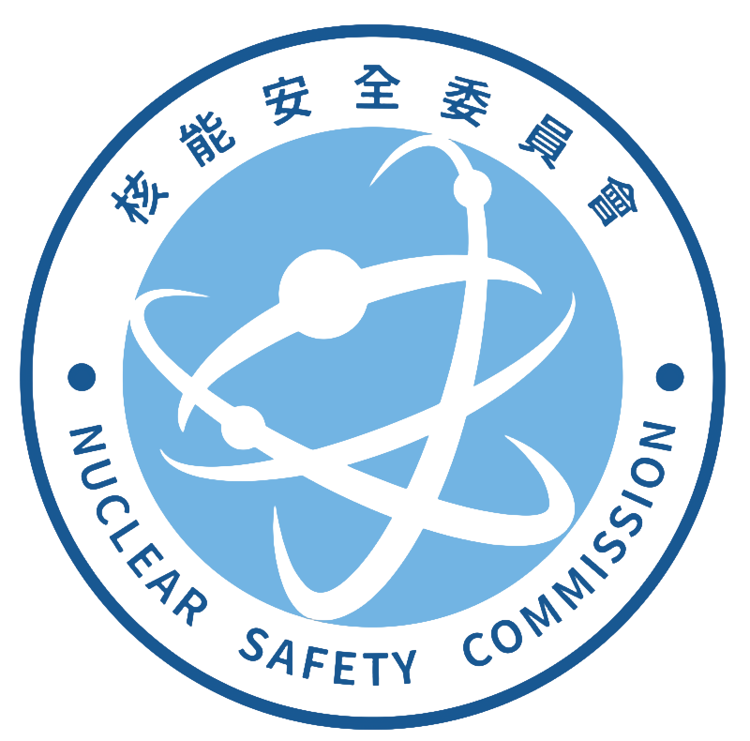
Radiation Monitoring Center, Nuclear Safety Commission
Address:833 No.823, Chengqing Rd., Niaosong Dist.,
Kaohsiung City 833, Taiwan (R.O.C.)
TEL:(07)370-9206 FAX:(07)370-2706
Application form for tissue free water tritium analysis in food sample
I. Basic information of the applicant agency RMC- BT-
Company(Chinese): | Company(English):
Responsible person: | Contact person:
Mailing address: | Business ID number
Telephone (including extension): | Date of Application:
II. Basic information of sample(s)
(1)Item Name(Chinese):________________ Item Name(English):_________________ Weight (number) amount：_______________
Sampling date：_________________ Batch number：__________________ Status：_____________________
Manufacture or expiration date：_________________ Place of origin：_______________ Package：_________________
(2)Item Name(Chinese):_______________ Item Name(English):__________________ Weight (number) amount：______________
Sampling date：_________________ Batch number：__________________ Status：_____________________
Manufacture or expiration date：___________________ Place of origin：_______________ Package：_________________
total__________________sample(s) Fee NTD $__________________
III. Testing Report(s) Format
⃞⃣Combined ⃞⃣Independent (Please select one item)
Reissue testing report of the same batch number： report(s)
(Fee of each report or supplementary report: NTD $250)
Letter of Credit No:_________________ or INV. No:_________________
IV. Comprehensive description
1.The applicant agency must first contact the organizer of the RMC by phone. After understanding the properties of the sample and accepting the commission with the consent of the RMC, the applicant will pay the fee. The sample belongs to the food category, the fresh weight is 700 gram (edible parts). If the sample is damaged or leaked due to transportation, the RMC will not be responsible, and the applicant agency should send the sample again.
2.According to the method of measurement：2024.6.25 Taiwan Food and Drug Administration release, Method of Test for Tissue Free Water Tritium in Foods (TFDAO0047.00).
3.The testing fee for each sample is NTD $ 5,000. It could be paid on-site, draft or postal transfer. Account number is 04317050. Account name is 核能安全委員會輻射偵測中心. The applicant agency should indicate applicant agency name and the testing item on the transfer form.
4.The reports and receipts issued by the RMC are all based on the information provided by the applicant agency, and others are rejected. If the payment is not completed, the RMC will not issue a report.
5.This operation shall be completed within 10 working days from the date of sample receipt. If the operation deadline is exceeded, the RMC will take the initiative to call the applicant agency to explain the processing progress and the reason for the delay.
8.Please select the method of delivery of the report: ⃞⃣ Retrieve on-site; ⃞⃣ Send by post.
9.Except for required by law, the RMC will keep confidential information about the performance of laboratory activities.
Application agency signature RMC signature Pay the fees(cashier)

